FEA Lab Project - Report

Project Name: FEA Lab Individual Project

Student Name: ___Aqib Iqbal__________________

Roll Number: _____ME-1906________________

Course / Department: ___Mechanical__________________

Instructor Name: _____Sir Affan________________

---

1. Abstract

This report presents the Static Structural and Explicit Dynamics analyses that I performed on a custom-designed polygonal model using ANSYS Workbench. The material properties were defined from my roll-number-based calculations, while the applied forces were derived from my date of birth for the static case and the USD→PKR exchange rate for the explicit case. I carried out a complete mesh-convergence study to ensure that all results were numerically reliable and independent of mesh density. The final outputs include detailed stress contours, deformation fields, kinetic/internal energy plots, and time-history graphs, with a comparison between static and dynamic responses. All project files, analysis models, screenshots, and documentation are included in this GitHub repository as part of the required submission.

2. Objective

- Create pentagon/hexagon geometry
- Assign custom material based on roll number
- Apply fixed support and remote force
- Perform Static Structural simulation
- Perform Explicit Dynamics simulation
- Perform mesh convergence study
- Compare static vs explicit results

3. Geometry Creation

This section describes how the geometry was created in ANSYS DesignModeler/SpaceClaim.

3.1 Polygon Sketch

The required polygon (Pentagon) was sketched on the YZ plane.
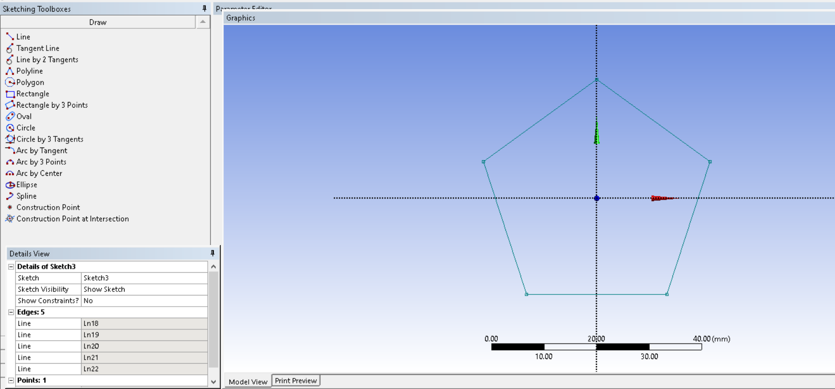

side length=43mm, each side

3.2 Extrusion to 3D Solid

The 2D sketch was extruded to a suitable thickness = 10 mm.
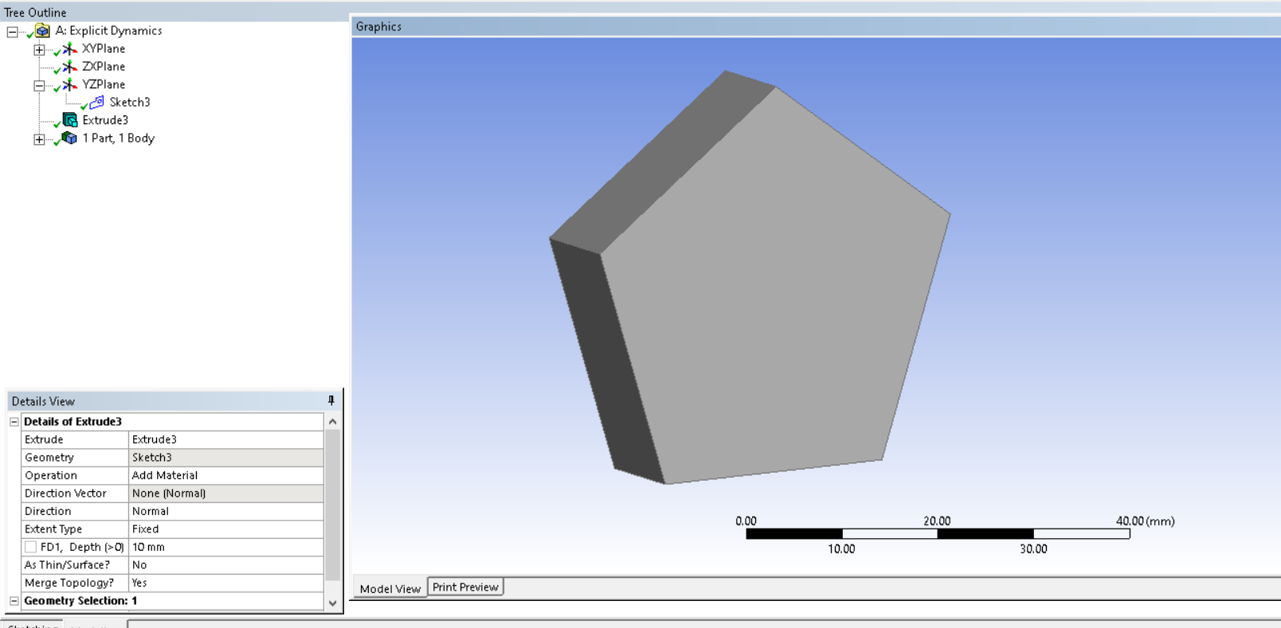
Software used: ANSYS DesignModeler / SpaceClaim
4. Material Properties
The right to choose material was totally based on me, so I choose Aluminum with Youngs Modulus(E): as per my roll number last digit × 10³
It goes like this 06 × 10³= 6000 Pa
Poisson’s Ratio: 0.28
Density: Standard Aluminum

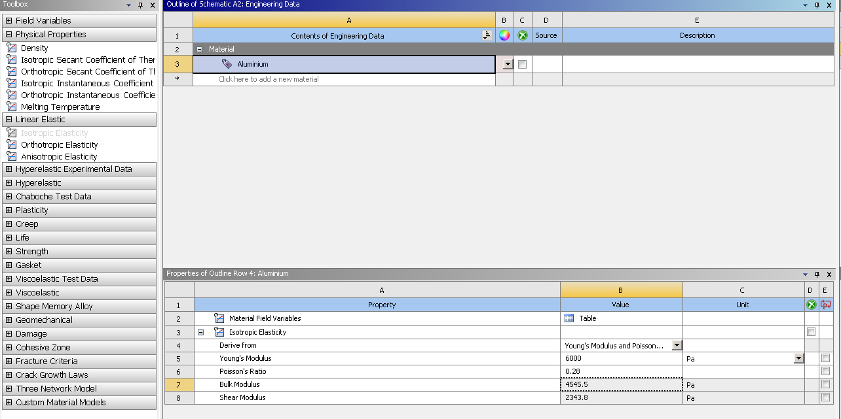

5. Boundary Conditions
For the Static Structural analysis, one face of the polygonal model was assigned a Fixed Support, fully restricting all translational and rotational degrees of freedom. A Remote Force was then applied at a reference point positioned at one-third of the fixed face, ensuring proper load transfer through kinematic coupling. The magnitude of this load was calculated from my date of birth, resulting in a final value of 2021 N, which was applied in the designated loading direction based on the model orientation. These boundary conditions provided stable and realistic constraints for accurately evaluating the structure’s static response.

5.1 Fixed Support
One of 5 faces was chosen as a fixed support
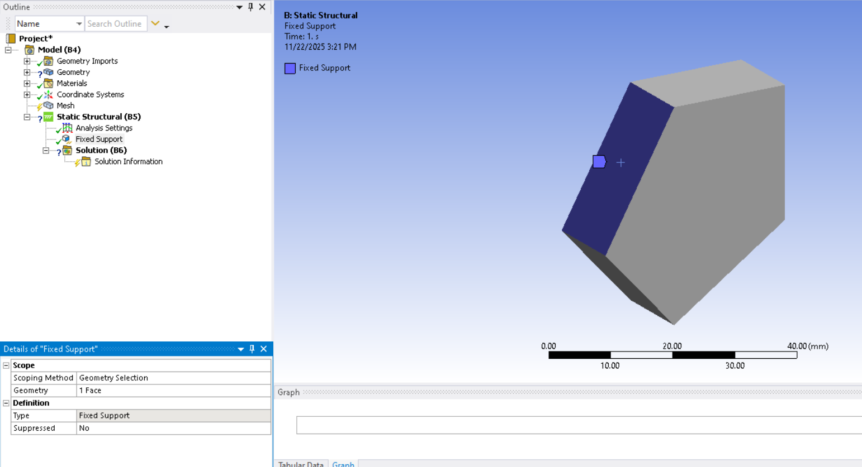

One entire flat face of the polygon was selected and fully fixed.

5.2 Remote Point Definition
The remote force has been applied on similar fixed face at position of 1/3
43mm/3 =14.33mm
Sum of my birthday, DOB Sum = (Day + Month + Year) = Load
Magnitude=2021N
The remote point acts as the point of force application.
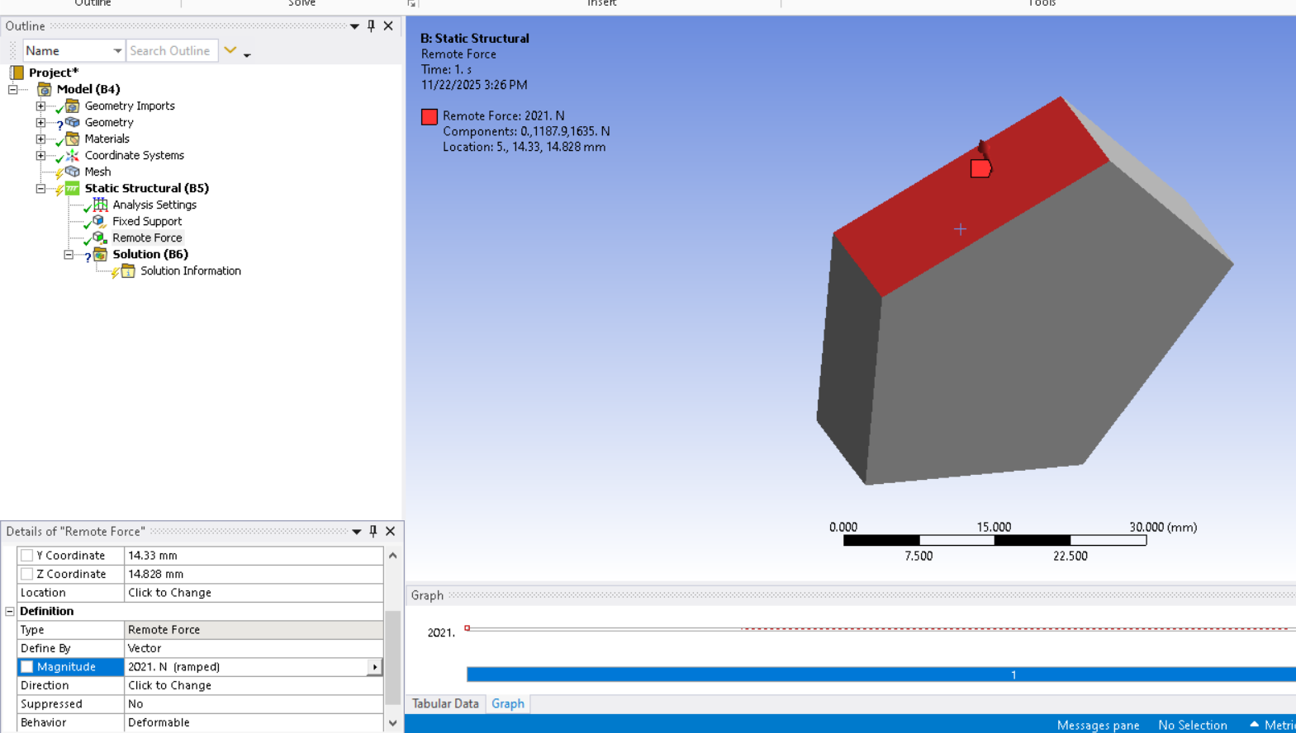

Explicit Dynamics Load

Magnitude taken as: USD→PKR exchange rate on analysis date
1USD= 285 Pkr (as per 22 Nov, 2025)
Load= 285N
Force was applied at 1/3rd as similar in static case

Load behavior was set as constant using a time-history table (0 s = 1, 0.2 s = 1)
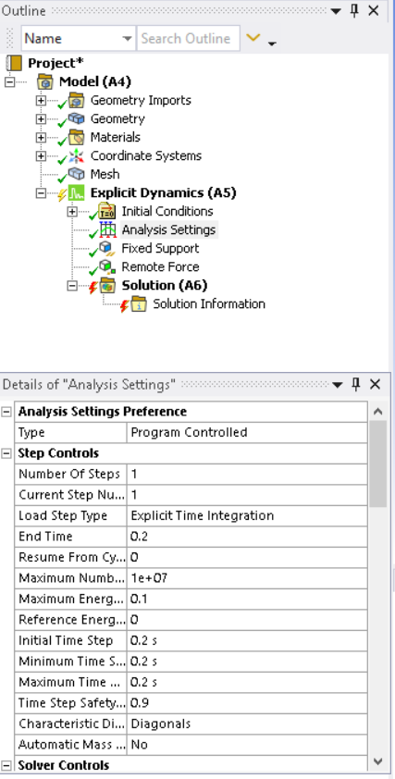
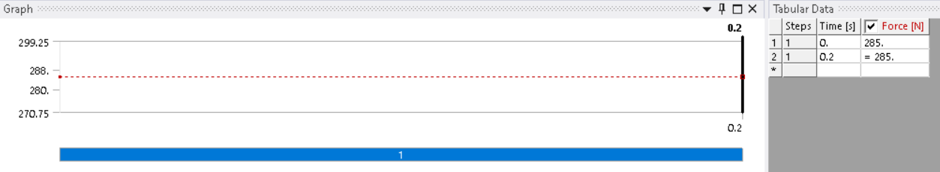

5.1 Fixed Support
In the Explicit Dynamics analysis, the same face used in the static study was constrained with a Fixed Support, preventing all translational and rotational motion throughout the simulation. This boundary condition ensured that the structure remained fully restrained at the base while dynamic loading was applied, providing a stable reference and allowing accurate evaluation of stress waves, deformation patterns, and energy response under time-dependent loading.
One side face fully constrained

6. Meshing
I’m choosing 1mm meshing size and also applying element quality.
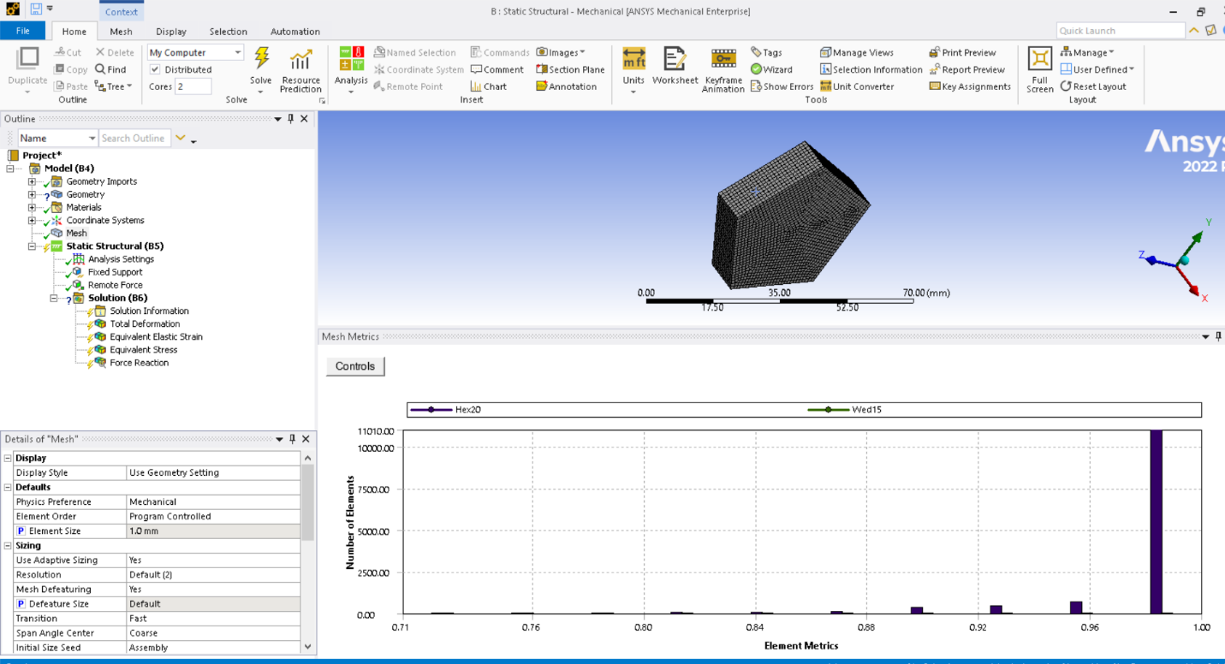
Reaction force results
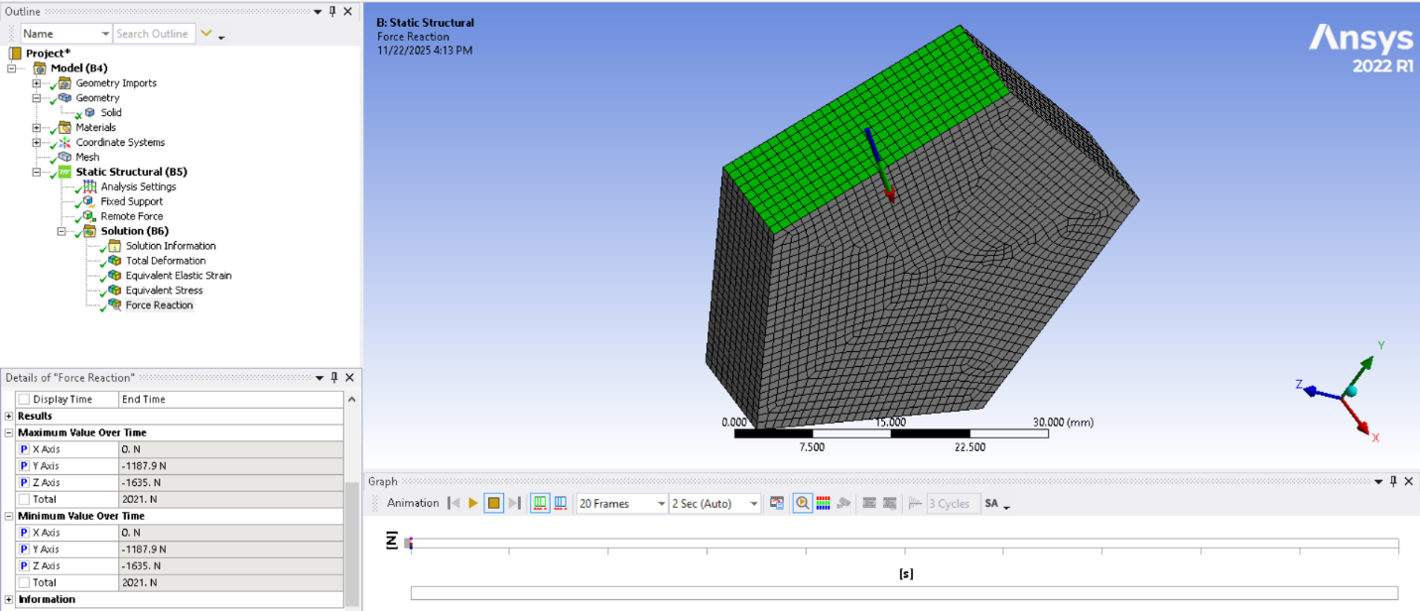
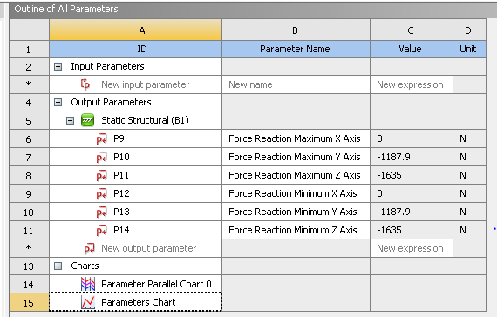

7. Explicit Dynamics Analysis
The Explicit Dynamics analysis used the same boundary-condition setup as the Static Structural case for consistency. The same face of the polygon was assigned a Fixed Support, fully restraining all degrees of freedom throughout the simulation. The load was applied at the same remote point located at one-third of the fixed face, but in this case the force was treated as time-dependent, following the total simulation time of 0.2 seconds. Aside from the time-step-based loading, the boundary conditions remained identical to the static analysis to allow a direct comparison of structural response under dynamic effects.
So, the only change will be in results.
Mesh Convergence of Static

